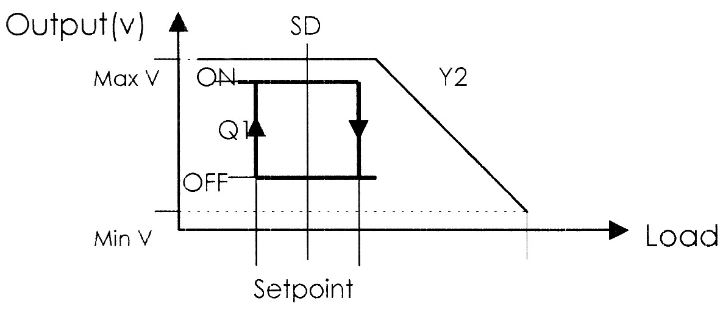
這點才是面板設定的 setppoint

這點是 Setpoint –P-band – 1/2 SD

Application 8 (mainly for heating control with 2 controlled devices in sequence)

Example : Main Heating 0-10 VDC + Auxiliary on-off heater
Setpoint = 20ºC, P-band = 3K, SD=2
sensing temp < setpoint then 0-10VDC PI output
aux. on-off output activates when sensing temp. drops below setpoint – P-band – ½ SD = 16ºC

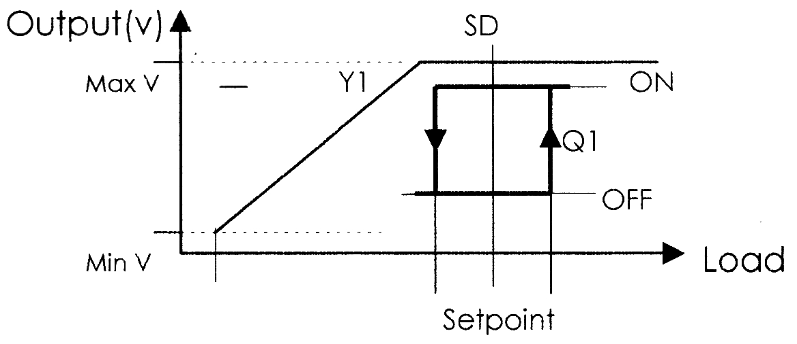
這點是 Setpoint + P-band + 1/2 SD

這點才是面板設定的 setppoint

Application 9 (mainly for cooling control with 2 controlled devices in sequence)

Setpoint = 20ºC, P-band = 3K, SD=2
sensing temp > setpoint then 0-10VDC PI output
aux. on-off output activates when sensing temp. rises above setpoint + P-band +1/2 SD = 24ºC

